1. 
2. Component is the most important concept.
3. **Component** = View (HMTL) + Style (CSS) + Code (That reacts to the user’s actions)  
   NOTE: Such reactive code is called view logic. Code is used to handle view actions.
4. 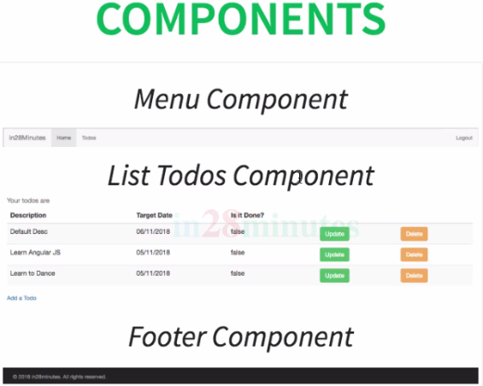
5. Let’s suppose we want to build this TODO Management App. This app is divided into components such as Menu, List Todos, footer components.
6. Each of these components is responsible for displaying the view which is basically the HTML, the styling which is CSS, as well as the code that reacts to the user actions.
7. 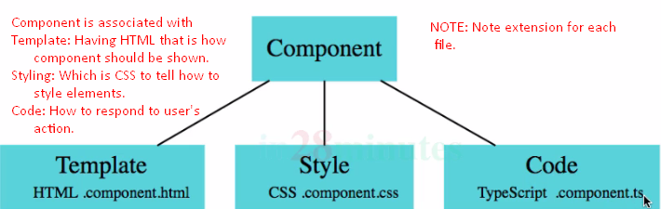
8. In angular, you tell that something is component using **decorator** @Component which is very much similar to annotation in java.
9. 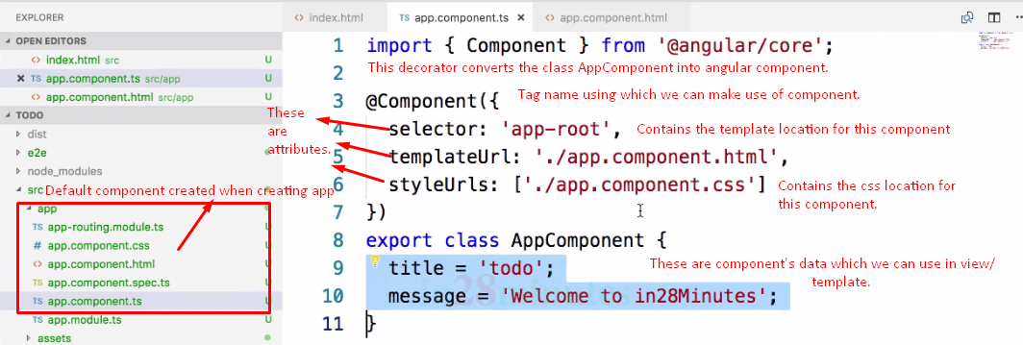
10. 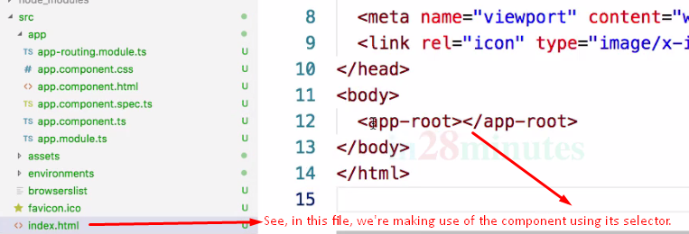
11. 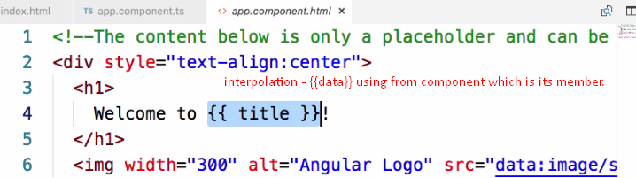
12. 
13. 